Sharing Soft Power Insights
By Edwin A. (Skip) Vincent, Brig Gen, USAF (Ret)

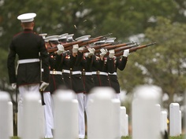
Few people appreciate the searing pain we in the military feel at the crack of a gun salute followed by the melancholy playing of taps as The Flag is presented to surviving family members at military funerals. This ceremony is all to frequent in the Special Operations community. Hollywood mostly portrays Special Operations personnel as action figure Rambo’s but this is far from a complete or accurate picture. In addition to being some of our most capable forces, Special Operators are some of our best, brightest and most introspective. They’ve learned over decades that winning the hearts and minds of people can achieve better and longer lasting results than kinetic military action. This is the essence of “Soft Power.”
Arlington National Cemetery
Soft Power enters the mainstream
The term “Soft Power” has been increasingly used by world leaders, academics and journalists to describe a “new way of thinking” in international relations and an alternative to Hard Power or military action. However, many don’t really understand what Soft Power is or how to implement it. So, from those us who’ve been in the trenches implementing both Hard and Soft Power we offer the following observations based on experience to answer the following questions: What is soft power? Is it really new? Why do we want to use it? Why has it become so popular and a "cool" term to use?
What is soft power?
“Soft power is the ability to attract and co-opt rather than coerce, use force or give money as a means of persuasion” (Nye, 2004). Its goal is “to provide community resiliency and stability through the co-creation of solutions involving energy, environment, medical, health, and economics.” This may sound a bit technical but Soft Power is simply using relationships between people and groups to initiate positive actions that help improve life in affected areas.
Is it really new?
Soft Power is not just a new term for diplomacy. For starters, politicians are generally drivers of diplomacy and they don’t necessarily understand or speak for the general population (Akin, 2005). While Soft Power can be used in traditional diplomacy, it goes much deeper. Soft Power strives to connect base level communities in need with partners who can help them achieve their goals. The local communities drive the process because they are the ones closest to the problem and will have to live with the results. The Soft Power partner is there to provide guidance, sometimes through financial assistance and training, or to help if the effort stumbles. The partner is not a “white knight” there to save the community from failure but an equal member of a team working to reach the common goal.
Why is soft power something that we want to pursue?
International aid provided by countries around the globe every year amounts to billions of dollars. Yet, there is an underlying concern that the help doesn’t reach the people who need it. The stories of waste, corruption and simple mismanagement are all too common. Major government agencies and large NGO’s (non-governments agencies) can move tremendous resources, but frequently the efforts and resources are supplied as soft actions not properly targeted and with poor accountability and follow-through. Often, the soft actions are well intentioned but they result in unhappy donors and unhappy recipients.
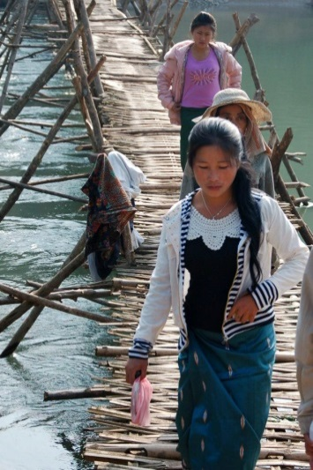
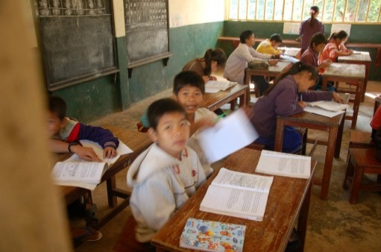
There is a misconception that Soft Power is the same as soft action. It is not. The key difference is accountability, metrics and a different philosophy. Soft Power targets the point of need but also adds a joint development and learning component to provide needed services and not just money. Guidance on how to grow crops instead of just handing out food that may never reach its destination, or work to build better homes and facilities in a devastated area instead of merely providing temporary shelters. It is aid that both the community and stakeholder partners contribute to, providing money and people to not only get things done, but also to learn better ways of doing for themselves. As a result, international aid expands its impact and transforms short-lived relief into a long-term investment in a community’s future.
Vietnam 2012, E. Kalinski
Vietnam 2012, E. Kalinski

Why has “Soft Power” become a "cool" term to use?

Perhaps the growing disillusionment we’ve seen with traditional international aid and military Hard Power is why “Soft Power” is a term that has come to the forefront. International aid is an incredibly expensive way to influence others as is military action. Yet, natural and man-made disasters continue as well as the desire to help but funding is limited. Soft Power is that new idea needed to continue international aid but that is long lasting and accountable. It can be cheaper and more effective in shaping the geopolitical environment. It leads to greater understanding among stakeholders and steers aid towards more significant and long lasting outcomes. It is a “whole of society” approach that can be practiced by governments, NGO’s and businesses.

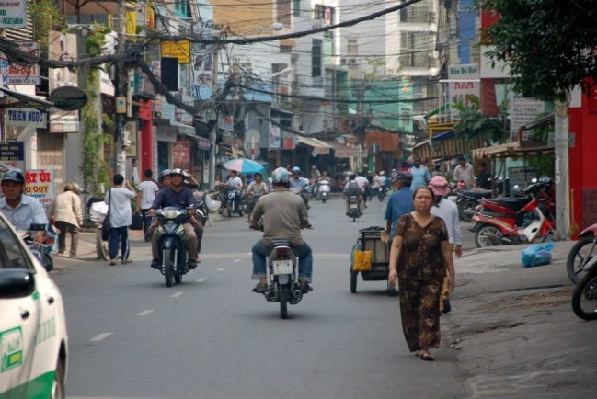
Summary
Vietnam 2012, E. Kalinski

There is still broad misunderstanding of the nature and implementation of “Soft Power.” The financial and human cost of Hard Power and feckless diplomatic actions is not sustainable. The potential benefits of “Soft Power” are too significant to ignore. It is an enabler to craft enduring solutions for new and emerging problems. It is how we should look at international relations – a partnership for the greater good of all.

Soft Power Solutions

My team and I continue to learn with each encounter. We’ve come to understand that Soft Power is a “whole of society” approach that builds enduring and stable communities. It is about resiliency and sustainability through capacity building that manages change, mitigates risks and promotes maturity and self-development. Most important, however, is that we have learned that Soft Power is not simply a new quantitative approach. Success depends on qualitative changes in philosophy underpinned by support organizations with sound leadership and accountability. Soft Power will continue to be redefined and re-visioned by anyone willing to share, influence, or lead. Positive outcomes resulting from the technology and actions will be celebrated. However, it’s not the outcomes alone that produce solutions; it’s the relationships and legacies built through the courage and actions of leaders and those involved that produce enduring solutions.

Brig Gen Vincent recently retired with 37 years of military service. He is the former assistant to the director of plans and policy, U.S. Pacific Command where he lead dozens of U.S. – Partner Nation bilateral engagements focused on Soft Power related challenges. He currently heads Soft Power Solutions, an organization that leadership and a whole of society approach towards Soft Power where he continues to engage governments and communities across the Pacific and Middle East.

Works Cited

Akin, J. a. (2005, January). "Diplomacy." Beyond Intractability. Retrieved from Eds. Guy Burgess and Heidi Burgess. Conflict Information Consortium, University of Colorado, Boulder. Posted: <http://www.beyondintractability.org/essay/diplomacy-intro>
Nye, J. (2004). Soft Power: The Means to Success in World Politics. New York: New York Public Affairs.

